Week 5: ARRAYS (1-D)
General Instructions:
1. Remove existing directories and create a fresh directory of your own. Write all the programs inside the newly created directory.
2. Remove the directory that you have created at the end of your Lab session.
3. Inform one of the TAs before you leave the Lab.
------------------------------------------------------------------------------------------------------------------------

- ARRAYS
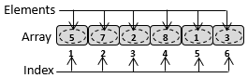
Fig. 1: Array

An array is a collection of a finite number of homogeneous data elements stored at contiguous memory locations. Homogeneous means, the data elements are of the same type. It is a linear data structure because its data elements are ordered as first, second, third, and so on. The data elements of an array are stored at contiguous memory locations linearly.
Index defines the location and ordering of the data elements. If the index of the first element is 1, the index of the second element is 2, the index of the third element is 3 and so on. The indexes of the first and last elements of an array are often referred to as lower bound (LB) and upper bound (UB) respectively. Figure 1 illustrates an example of an array with 5, 7, 2, 8, 1, 3 data elements, and its LB and UB as 1 and 6, respectively. The first element 5 is stored at index LB=1. The second element 7 is stored at the index LB+1, the third element 2 at the index LB+2, and so on. The last element 3 is stored at the index UB. The number of data elements in an array is defined by (UB-LB+1)=(6-1+1)=6.
The data element at any arbitrary location can be accessed using its index, without visiting other elements in the array. Therefore, the method of accessing data elements of an array is also referred to as the random access method. If the name of an array is A, the first element of A can be accessed as A[LB], the second element as A[LB+1], and so on. The number of elements in the array is limited by the amount of memory allotted for the array in the memory.

1.1 Types of Array
An array can be defined as a one-dimensional (1D) array or a multi-dimensional array (more than one dimension). Figure 1 defines an example of a 1D array. A two-dimensional (2D) array is defined as an array of 1D arrays. Likewise, a three-dimensional array is defined as an array of 2D arrays, and so on. Figure 2 illustrates 1D, 2D, and 3D types of arrays pictorially.
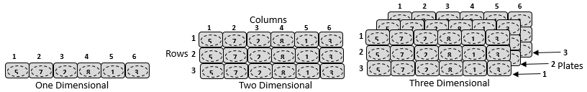
Fig. 2: Types of Array

While a 1D array is defined as $A[Columns]$ where Columns represent the number of data elements, a 2D array is defined as $A\left[Rows\right][Columns]$, where Rows represent the number of 1D arrays. The sizes of constituent 1D arrays are same. Likewise, 3D array is defined as $A\left[Plates\right]\left[Rows\right][Columns]$, where Plates represent the number of 2D arrays of the same sizes. In the similar way, higher order array can be defined. In C/C++ programming language, 1D, 2D, and 3D arrays of integer types can be defined like int A[10], int A[5][10], and int A[3][5][10] respectively. The n $5×10$￼$3×5×10$￼. In general, the order of an array of a k$n_{k}×n_{k-1}×n_{k-2}×…{n_{2}×n}_{1}$￼$n_{i}$￼ represents$i^{th}$￼dimension.
1.2 Representation of Arrays in Memory
One-dimensional Array: Let A be an array of size n. Let the datatype of its data elements be Type, which needs k number of bytes. While defining the array A, a memory of size $n×k$ will be allocated in a contiguous memory location in the computer’s memory (i.e., main memory). Figure 3 illustrates allocation of an integer array of 5 elements. It is assumed that an integer datatype needs 2 bytes of memory. In this example, the base address, the starting memory address of the array is 1000. Each memory location has one byte of storage. Therefore, the bytes at the location 1000 and 1001 together store the first element of the array i.e., A[0], assuming LB=0. Similarly, successive two bytes of storage store the successive elements.

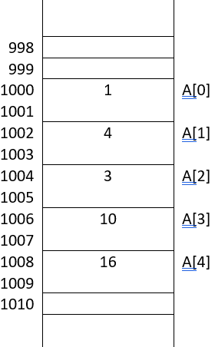
Fig. 3: Allocation of an integer array of 5 elements in memory. The lower bound is assumed to start from 0, and {1, 4, 3, 10, 16} are the elements in the array. Each element consumes two bytes of memory.

Since the elements are stored at consecutive memory locations, the memory address of the $i^{th}$element of the array can be estimated as below.
$Address of A\left[i\right]=base address+(i-LB)×k$
where k is the byte required for the underlying datatype. In the above example, base address is 1000, $k=2$
and $LB=0$.
The address of A[3] is $1000+(3-0)×2=1006$
The address of A[3] will be $1000+(3-1)×2=1004$.
In general, the name of the array represents the address of the first element.

Example 1: Understanding memory allocation of a 1D array.
Let us consider the following array declaration in C/C++ programming language to define the example shown in figure 3. The index starts from 0, i.e., $LB=0$.
int A[5];
The array variable name A represents the address of the first element in the array. Therefore, the following two printf statements will print the same data element 1.
printf("%d", A[0]);
printf("%d",*A);
Similarly, $A[1]$
and $*(A+1)$
will point to the second data element 4. Therefore, $A[i]$ and
$*(A+i)$
point to the same $i^{th}$
data element.

1.4 Operations on a Linear Array (1D Array)
Insertion: An insertion operation on an array is referred to as adding an element at a particular index position in the array. Insertion can be made at the first position, intermediate position or after the last element. The number of elements that can be accommodated in an array is defined by the contiguous memory storage that has been reserved for the array. Insertion of an element at the index $i≥0$ will result in shifting all the elements stored at the index $i$ and higher by one position towards the tail of the array to create space for the new element. Figure 12 illustrates the insertion of an element at the index $i=0$. Let $n=UB-LB+1=7-0+1=8$ be the number of elements in the array before insertion, then insertion at the index $i≥0$ will result in shifting $n-i$ (i.e., $UB-i+1$) number of elements. In the example in Figure 12, eight elements need to be shifted by one position. Therefore, time complexity of inserting an element at an arbitrary index $i≥0$ in an array with $n$ elements is $O(n)$. It holds best case time complexity (insertion at the end i.e., no shifting, but only storing the element) of $O(1)$, and average (half of the elements are moved) and worst case (all the elements are moved) time complexity of $O(n)$.
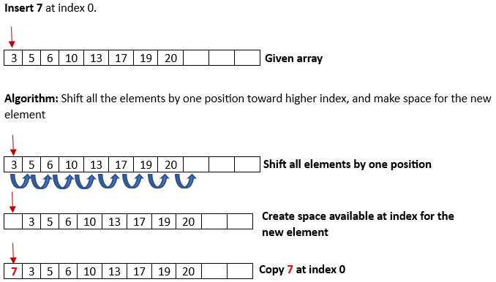
Fig. 12: Insertion of an element at the beginning of an array.

An algorithm for inserting an element at an arbitrary index $i≥0$ is given below.
Input: Array A, index i, element ele
BEGIN
Step - 1: Repeat for k=UB to i
Step - 2: A[k+1]=A[k]
Step - 3: End Repeat
Step - 4: A[i] = ele
Step – 5: UB=UB+1
END

Deletion: A deletion operation on an array will remove an element from the array at a particular index $i$. Deleting an element at the end will not disturb the other elements, except that UB will be reduced by 1. Whereas, deleting an element at an arbitrary index $i$ will result in shifting all the elements from $i+1$ to $UB$ by one position towards the beginning. Figure 13 illustrates deleting an element at an arbitrary index $i$. If there are $n$ number of elements in an array, the time complexity for deleting an element at an arbitrary index $i≥0$ is $O(n)$. It holds best case time complexity (deleting at the end i.e., no shifting, but UB update) of $O(1)$, and average (half of the elements are moved) and worst case (all the elements are moved) time complexity of O$(n)$.
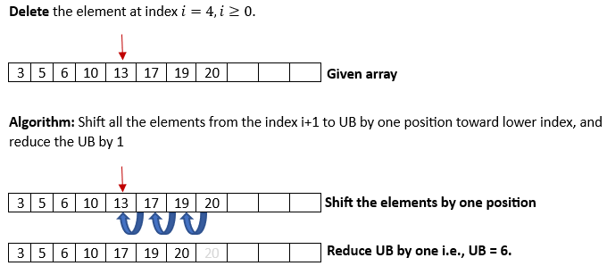
Fig. 13 Deleting an element at an arbitrary index.

An algorithm for deleting an element at an arbitrary index $i≥0$ is given below.
Input: Array A, index i
BEGIN
Step - 1: Repeat for k=i to UB-1
Step - 2: A[k]=A[k+1]
Step - 3: End Repeat
Step - 4: UB=UB-1
END

Update operation of an element at index $i$ simply changes the value at $i$ with a new value. It does not affect the elements at the other indices. For example, $A\left[i\right]=new value$. As it needs only one assignment, it holds a time complexity of $O(1)$ irrespective of the index position.

How to declare an array?

Syntax of Array Declaration
data_type array_name [size];
or
data_type array_name [size1] [size2]...[sizeN];

where N is the number of dimensions.
dataType arrayName[arraySize];
For example,
float mark[5];
Here, we declared an array, mark, of floating-point type. And its size is 5. Meaning, it can hold 5 floating-point values. It's important to note that the size and type of an array cannot be changed once it is declared.

Example of Array Declaration
// C Program to illustrate the array declaration
#include <stdio.h>
int main()
{
// declaring array of integers
int arr_int[5];
// declaring array of characters
char arr_char[5];

return 0;
}

How to initialize an array?
There are multiple ways in which we can initialize an array in C.

1. Array Initialization with Declaration
In this method, we initialize the array along with its declaration. We use an initializer list to initialize multiple elements of the array. An initializer list is the list of values enclosed within braces { } separated b a comma.
data_type array_name [size] = {value1, value2, ... valueN};

2. Array Initialization with Declaration without Size
If we initialize an array using an initializer list, we can skip declaring the size of the array as the compiler can automatically deduce the size of the array in these cases. The size of the array in these cases is equal to the number of elements present in the initializer list as the compiler can automatically deduce the size of the array.
data_type array_name[] = {1,2,3,4,5};

The size of the above arrays is 5 which is automatically deduced by the compiler.

3. Array Initialization after Declaration (Using Loops)
We initialize the array after the declaration by assigning the initial value to each element individually. We can use for loop, while loop, or do-while loop to assign the value to each element of the array.
for (int i = 0; i < N; i++) {
array_name[i] = valuei;
}

Example of Array Initialization in C
// C Program to demonstrate array initialization
#include <stdio.h>

int main()
{

// array initialization using initializer list
int mark[5] = { 19, 10, 8, 17, 9 };

// array initialization using initializer list without
// specifying size
int arr1[] = { 1, 2, 3, 4, 5 };

// array initialization using for loop
float arr2[5];
for (int i = 0; i < 5; i++) {
arr2[i] = (float)i * 2.1;
}
return 0;
}

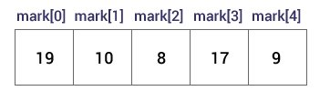Initialize an Array
Here,
mark[0] is equal to 19
mark[1] is equal to 10
mark[2] is equal to 8
mark[3] is equal to 17
mark[4] is equal to 9

Access Array Elements
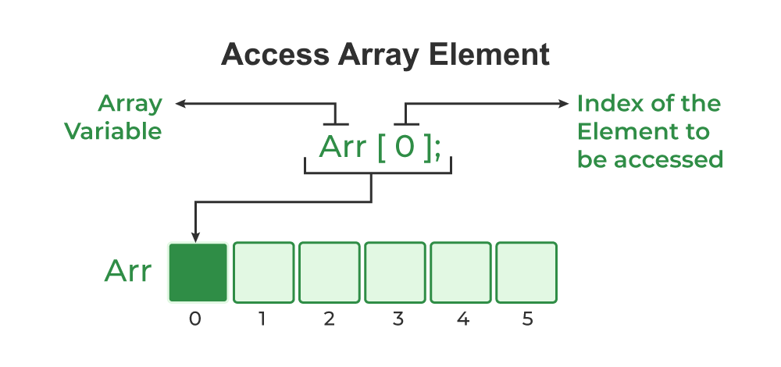
You can access elements of an array by indices.
Suppose you declared an array mark as above. The first element is mark[0], the second element is mark[1] and so on.
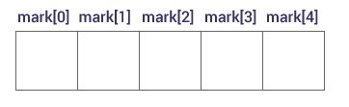Declare an Array

Few keynotes:
- Arrays have 0 as the first index, not 1. In this example, mark[0] is the first element.
- If the size of an array is n, to access the last element, the n-1 index is used. In this example, mark[4]
- Suppose the starting address of mark[0] is 2120d. Then, the address of the mark[1] will be 2124d. Similarly, the address of mark[2] will be 2128d and so on.
This is because the size of a float is 4 bytes.

Example of Accessing Array Elements using Array Subscript Operator
// C Program to illustrate element access using array
// subscript
#include <stdio.h>

int main()
{

// array declaration and initialization
int arr[5] = { 15, 25, 35, 45, 55 };

// accessing element at index 2 i.e 3rd element
printf("Element at arr[2]: %d\n", arr[2]);

// accessing element at index 4 i.e last element
printf("Element at arr[4]: %d\n", arr[4]);

// accessing element at index 0 i.e first element
printf("Element at arr[0]: %d", arr[0]);

return 0;
}

Output
Element at arr[2]: 35
Element at arr[4]: 55
Element at arr[0]: 15

Change Value of Array elements
int mark[5] = {19, 10, 8, 17, 9}

// make the value of the third element to -1
mark[2] = -1;

// make the value of the fifth element to 0
mark[4] = 0;

How to use Array in C?
The following program demonstrates how to use an array
// C Program to demonstrate the use of array
#include <stdio.h>

int main()
{
// array declaration and initialization
int arr[5] = { 10, 20, 30, 40, 50 };

// modifying element at index 2
arr[2] = 100;

// traversing array using for loop
printf("Elements in Array: ");
for (int i = 0; i < 5; i++) {
printf("%d ", arr[i]);
}

return 0;
}
Output
Elements in Array: 10 20 100 40 50
Array of Characters (Strings)
In C, we store the words, i.e., a sequence of characters in the form of an array of characters terminated by a NULL character. These are called strings in C language.
// C Program to illustrate strings
#include <stdio.h>

int main()
{

// creating array of character
char arr[6] = { 'I', 'I', 'T', 'G', '\0' };

// printing string
int i = 0;
while (arr[i]) {
printf("%c", arr[i++]);
}
return 0;
}
Output
IITG

Input and Output Array Elements
Here's how you can take input from the user and store it in an array element.
// take input and store it in the 3rd element
​scanf("%d", &mark[2]);

// take input and store it in the ith element
scanf("%d", &mark[i-1]);

Here's how you can print an individual element of an array.
// print the first element of the array
printf("%d", mark[0]);

// print the third element of the array
printf("%d", mark[2]);

// print ith element of the array
printf("%d", mark[i-1]);

Example 1: Array Input/Output
// Program to take 5 values from the user and store them in an array
// Print the elements stored in the array

#include <stdio.h>

int main() {

int values[5];

printf("Enter 5 integers: ");

// taking input and storing it in an array
for(int i = 0; i < 5; ++i) {
scanf("%d", &values[i]);
}

printf("Displaying integers: ");

// printing elements of an array
for(int i = 0; i < 5; ++i) {
printf("%d\n", values[i]);
}
return 0;
}
Output
Enter 5 integers: 1
-3
34
0
3
Displaying integers: 1
-3
34
0
3
Here, we have used a for loop to take 5 inputs from the user and store them in an array. Then, using another for loop, these elements are displayed on the screen.

Example 2: Calculate Average
// Program to find the average of n numbers using arrays

#include <stdio.h>

int main() {

int marks[10], i, n, sum = 0;
double average;

printf("Enter number of elements: ");
scanf("%d", &n);

for(i=0; i < n; ++i) {
printf("Enter number%d: ",i+1);
scanf("%d", &marks[i]);

// adding integers entered by the user to the sum variable
sum += marks[i];
}

// explicitly convert sum to double
// then calculate average
average = (double) sum / n;

printf("Average = %.2lf", average);

return 0;
}

Output
Enter number of elements: 5
Enter number1: 45
Enter number2: 35
Enter number3: 38
Enter number4: 31
Enter number5: 49
Average = 39.60

Here, we have computed the average of n numbers entered by the user.

